**MMC (Market Margin Calculator)**

**Monthly refresh**

The new catalogue is refreshed every month around the 12th day. If this is in the weekend the first Monday after that it will be refreshed.

Pls contact: [laneen.carty@philips.com](mailto:laneen.carty@philips.com) if there are any issues.

**Data Download**

First step is to download the master data from the C&Q website[Link](https://share-intra.philips.com/sites/STS20150513121511/default.aspx)

These are the files you need to download:

* The master data files for each Market: [Link](https://share-intra.philips.com/sites/STS20150513121511/MasterData/default.aspx) ; Contact: [laneen.carty@philips.com](mailto:laneen.carty@philips.com)

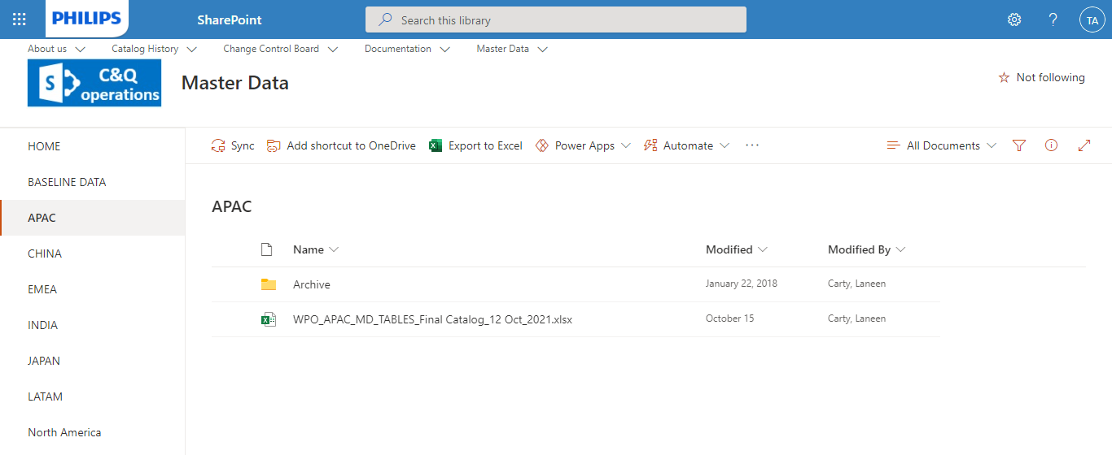

* The CFD translation file and the System Attributes: [Link](https://share-intra.philips.com/sites/STS20150513121511/MasterData/General/Forms/AllItems.aspx?viewpath=%2Fsites%2FSTS20150513121511%2FMasterData%2FGeneral%2FForms%2FAllItems%2Easpx&id=%2Fsites%2FSTS20150513121511%2FMasterData%2FGeneral%2FStandard%20Tables) ; Contact: [joyce.fransen@philips.com](mailto:joyce.fransen@philips.com)

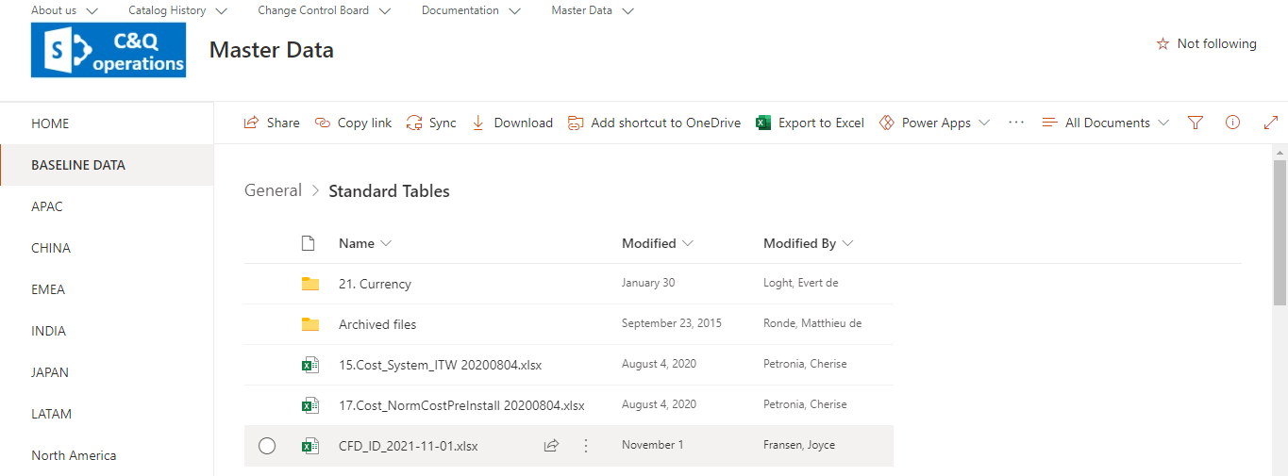

* For catalogue content we now use catalogue content per market files: [Link](https://share-intra.philips.com/sites/STS20150513121511/Reporting/Forms/AllItems.aspx?viewpath=%2Fsites%2FSTS20150513121511%2FReporting%2FForms%2FAllItems%2Easpx&id=%2Fsites%2FSTS20150513121511%2FReporting%2FCatalog%20Content%2FCatalog%20Content%20per%20Market) ; Contact: [joyce.fransen@philips.com](mailto:joyce.fransen@philips.com)

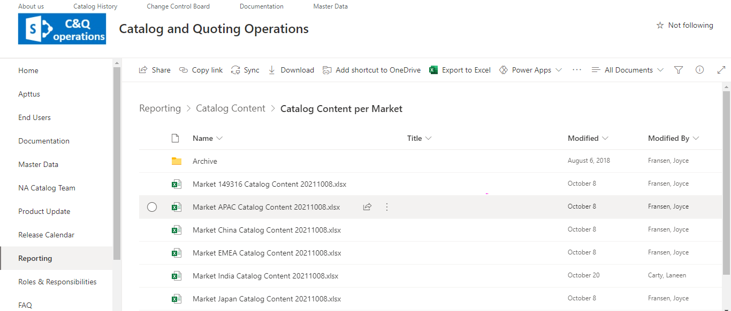

Second step is to download the PLI & Norms data from Teams,

* PLI, System Norms & Fallback Norms data: [Link](https://teams.microsoft.com/_#/files/General?threadId=19%3A5424efc35c2441ee972fb47bb2f714d4%40thread.tacv2&ctx=channel&context=PLI%2520%2526%2520Norms%2520Input%2520Files&rootfolder=%252Fsites%252FOneBICR-AdditionofNormsPLI%252FShared%2520Documents%252FGeneral%252FPLI%2520%2526%2520Norms%2520Input%2520Files) ; Contact: [twan.swinkels@philips.com](mailto:twan.swinkels@philips.com)

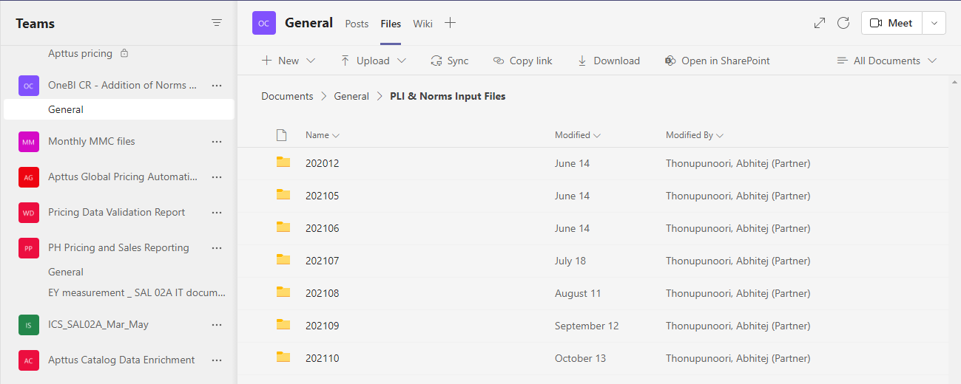

**Qlikview disc file structure:**

Files are placed on the link given below

\\qv-dev.share.qlik.philips.com\share\QV_DEV\Source Documents\NotQDF\CPQ\MMC\Qlikview_Orignal

Please copy the whole Qlikview folder in your system

Storage location

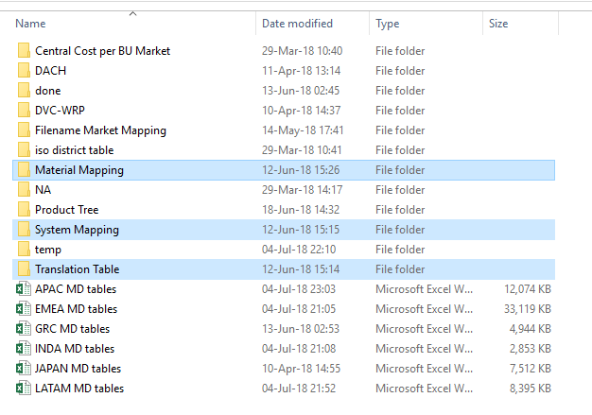  
  
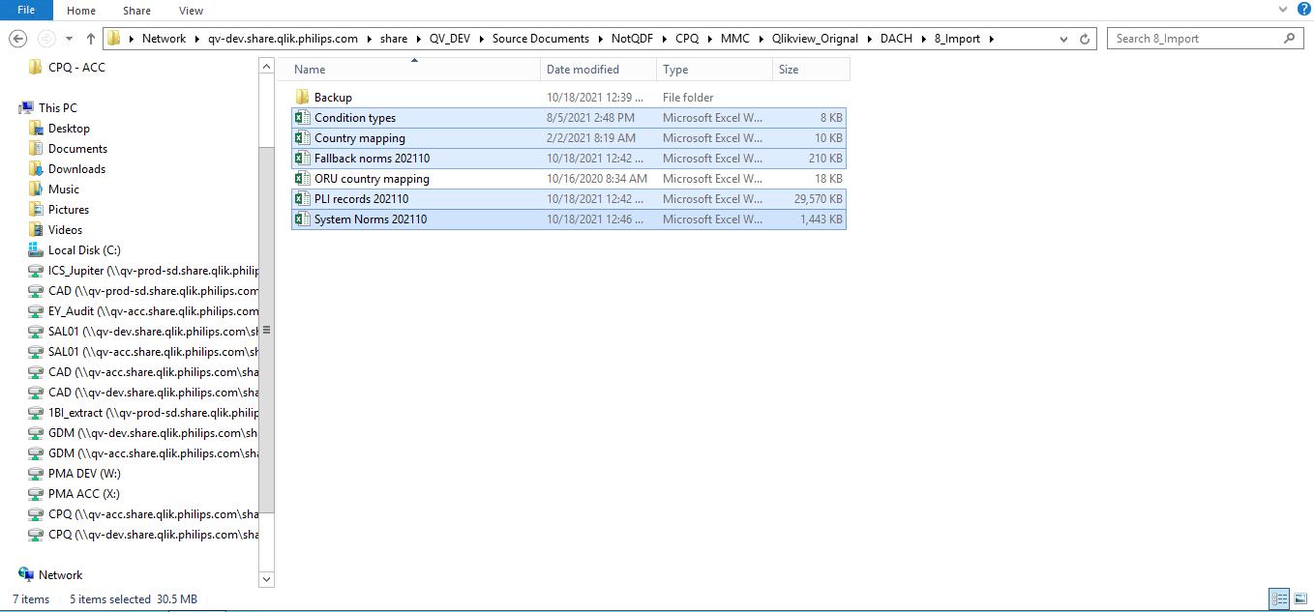

* The name of the general directory is “Qlikview_Original”
* The market files are stored in the root of this directory
* The CFD file is stored in the Translation Table directory
* The System attributes file is stored in the System Mapping directory
* The Catalogue Content overview is stored in the Material Mapping directory
* Fallback, PLI, System Norms are stored in 8_Import directory

### **Other Directories**

* The Iso district table directory holds the country BMC mapping table. When countries are assigned to a new BMC you need to update this file. Normally this does not happen.
* The Product Hierarchy table should be downloaded from [Link](https://share.philips.com/sites/TS0808220757592080427802/Publications/DataCharters/Product%20Tree.aspx) ; Go to Product tree & select the inputs as shown in below image, Extract the data & place in Product Tree folder.

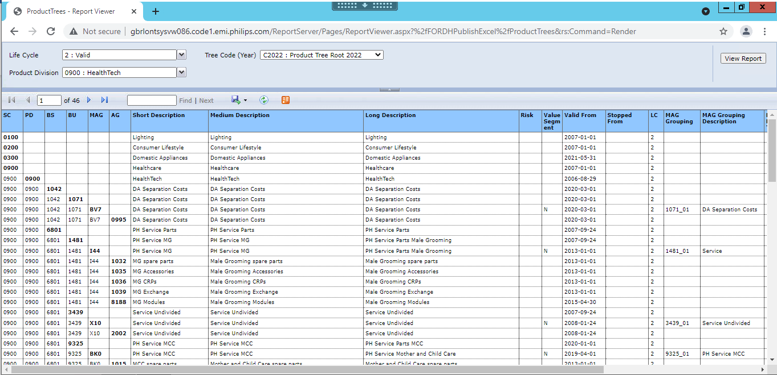

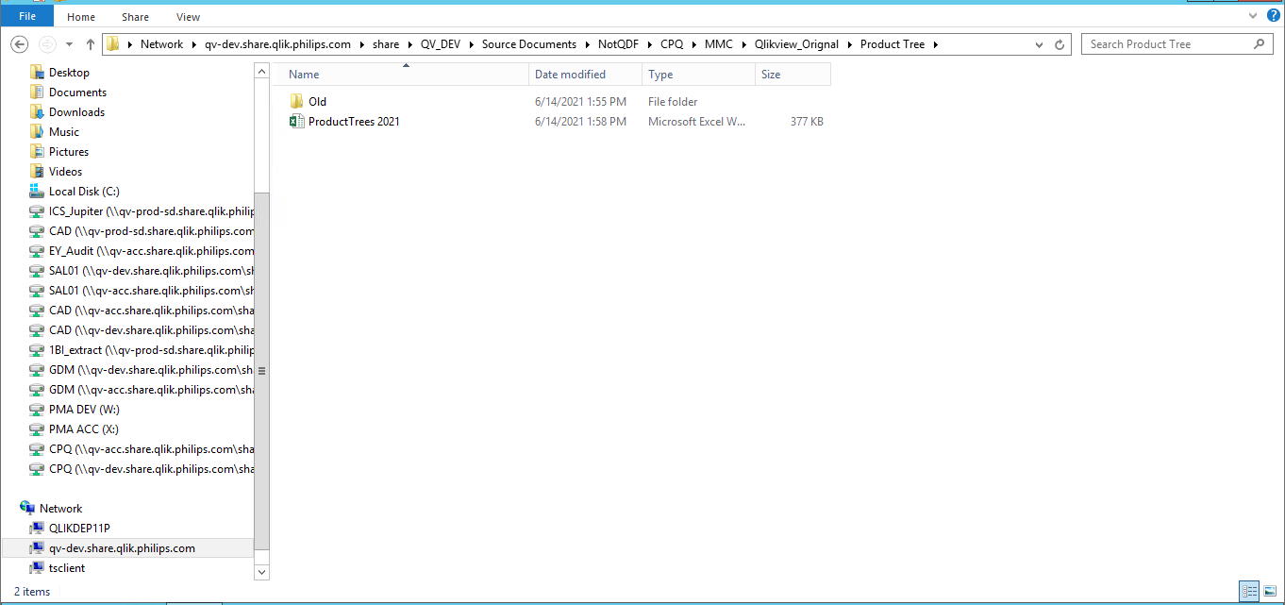

* The Filename market-mapping directory holds the names of the market files and the BMC they belong to. The names of the market master data files need to match the name of the file. Either you can re-name the files or re-work the directory. Current setting:

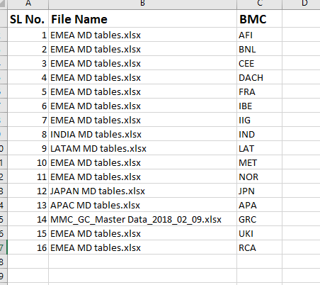

* The DVC WRP directory hold files that have the current WRP and DVC for IS. Currently this is not used, so the file holds old data. When we need this, we can simply update the file with data from SAP Core.
* NA holds North American data and is not used
* Done, and Temp are directories that we use to store previous month files

Fuzail note: Done and Temp folders are not available

### **Preparation of the files (**[**Link**](https://share-intra.philips.com/sites/STS20150513121511/MasterData/default.aspx)**)**

The market files need to check for compliance.

Typically, these defects exist.

* In all the files, except for EMEA, in the sheets 15. To 20. You need to add the column BMC related to the files
  + ISC in India-
  + GRC in China: China files are updated every quarter
  + LAT in Latam
  + APA in APAC
  + JAP for JAPAN
* For EMEA you only need to add the column names
* For all files you need to ad column names ‘BU code’ and ‘Group Name’ to the sheets 16. 18. and 19. 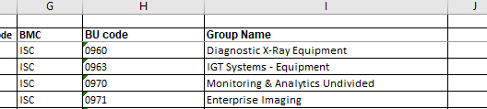
* In ISC (India) you need to check sheet name 8.CSAF It has a space between 8. and the ‘CSAF’ this should be removed.

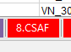

* In the Master data file, you need to make sure that in the 35. Sheets there is only one price list per country.

Table with two currencies in one tab:

Before:

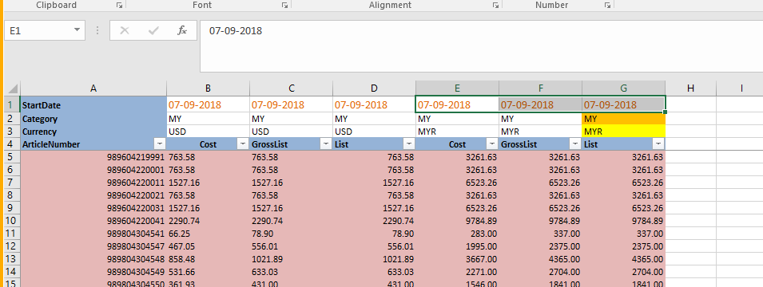

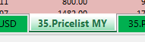

After:

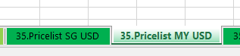

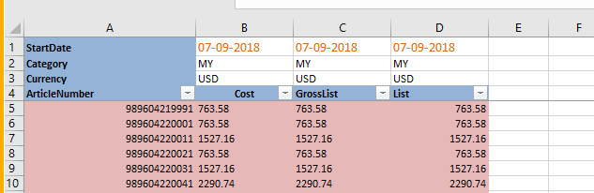

* Compare all three files sent by Twan with previous month data for file name, sheet names, headers and range of columns match.
* If any column with static data is missing then just add it.

## Preparation of the Load:

In the Directory ‘DACH’ you will find these directories:

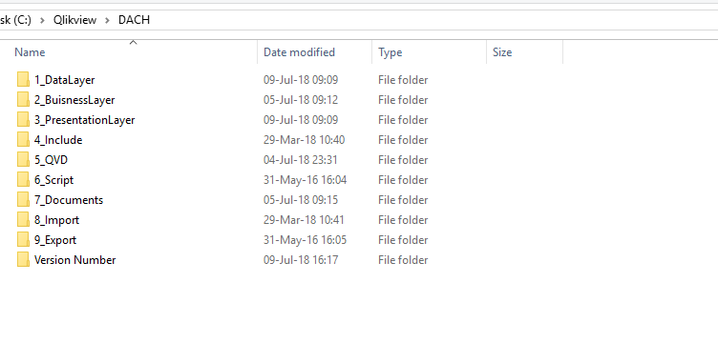

* Before we run the data layer we need to remove any old files from the directories ‘5_QVD’ and ‘7_Documents’
* In the folder ‘Version Number’ you need to open the excel file and set the version number name for this month.

## Load:

* First step is to run the DataLayer. When this has run without errors, you can close the files

Input for data layer: Excel downloaded MD files and Catalog files

Output from data layer: QVD files stored in 5_Qvd folder

Fuzail note: //CALL QVD_SECTION comment out

* Second step is to run the Business layer. When this has run without errors, you need to save it.
* Input for business layer: Output Qvd files of data layer
* Output from business layer: Price list files stored in 7_document folder
* Fuzail note: remove first row of system mapping file
* Last step is to run the Presentation layer. When refreshed you can save this.

Data: binary load of business layer and the output in the form of presentation view

### Sending the data:

When done you need to send 6 files in a ZIP file to the back office.

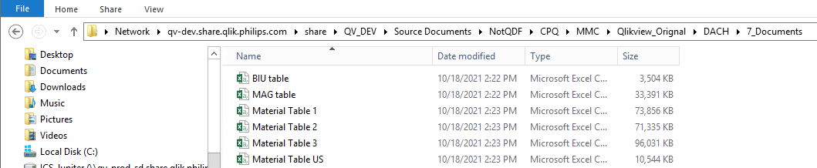

[partner.shefeenamol.vk@philips.com](mailto:partner.shefeenamol.vk@philips.com)

also include in the email the list of the number count per country. You can download this from the presentation layer.

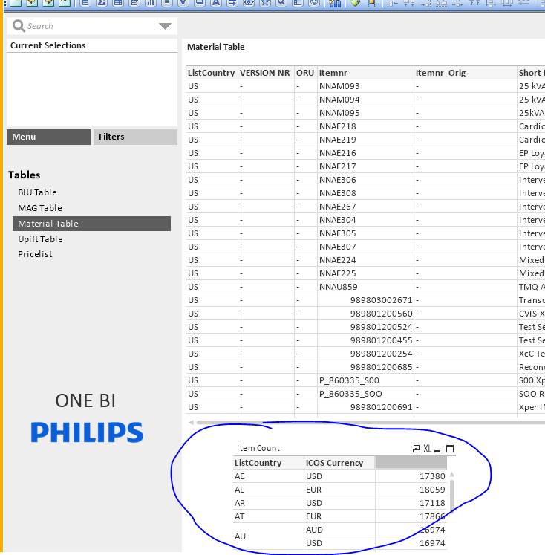

Distributing the price files:

On the MMC SharePoint you need to store the price files per country: [Link](https://share.philips.com/sites/STS020170130094002/MMC/SitePages/Home.aspx)

You also need to take backup of previous month’s price file on this link : [Link](https://share.philips.com/sites/STS020170130094002/ArchivePricelists/APAC/Forms/AllItems.aspx?id=%2Fsites%2FSTS020170130094002%2FArchivePricelists%2FAPAC%2FDecember%202018)

You can delete the old files and place the new file from the Folder ‘7_Documents’ onto the SharePoint.

### Communication

When done and you’ve got a confirmation that all the files have been loaded in the SQL database you need to send an email to all users that they can start with the refresh of the system.

Once all the activity is done, send One BI presentation layer to Michiel, dirk and Rob.

The master list is stored on the MMC SharePoint Link

**Post Input File Processing:**

1. Replace Master Data files inside Qlikview_Original folder.

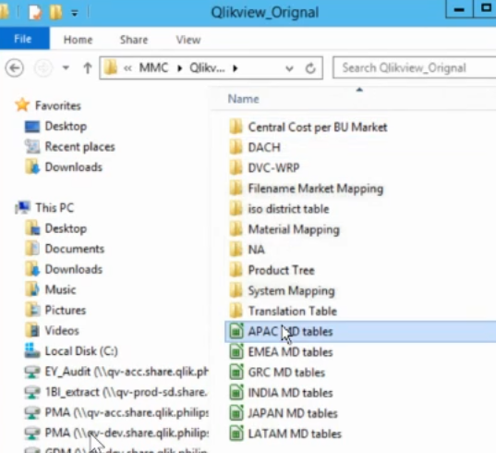

1. Inside

Qlikview_Original => DACH => 8_Import

Place norms data after taking previous month backup.

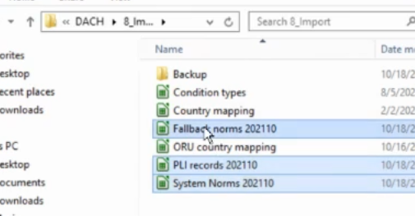

1. Inside

Qlikview_Original => System Mapping

Place System Attributes after taking old file into backup.

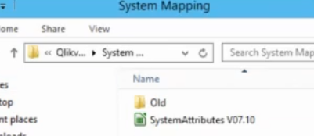

1. Inside

Qlikview_Original => Translation Table

Place CFD file after backup of old file.

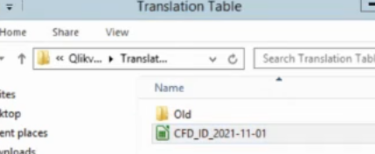

1. Inside

Qlikview_Original => Material Mapping

Place Catalog Contents file post backup of old data.

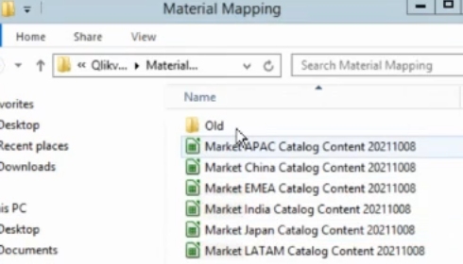

1. Inside 7_Documents delete whole data.

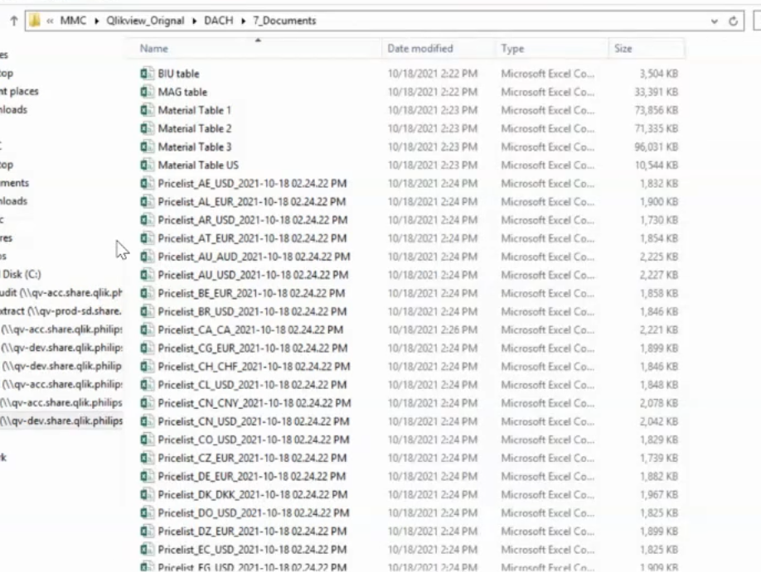

1. Inside QVD:

* Delete all the QVDs and copy last month 3 three QVDs from **ARCHIVE** folder and remove date in the name.

1. Inside DACH -> Version Number, update date.

**Data Layer:** Run PLI & Norms Data Layer.

Run OneBI_DL_v6_32_test-sk_UPD

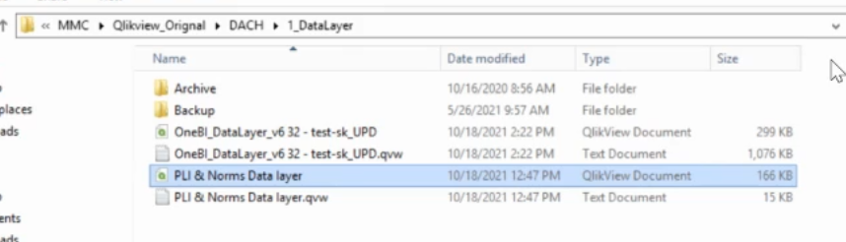

**Business Layer:**

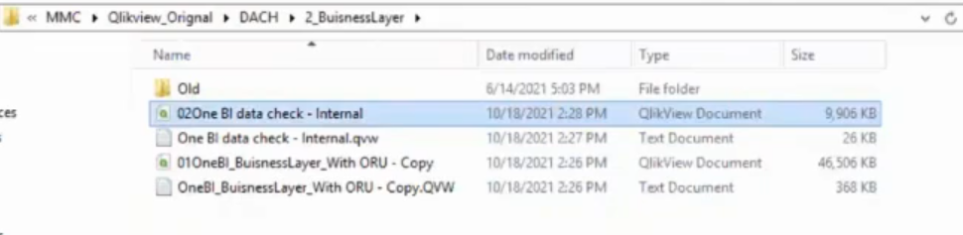

**Presentation Layer:** 2. One BI Post Load Check- output counts file with cond “YES” for Twan.

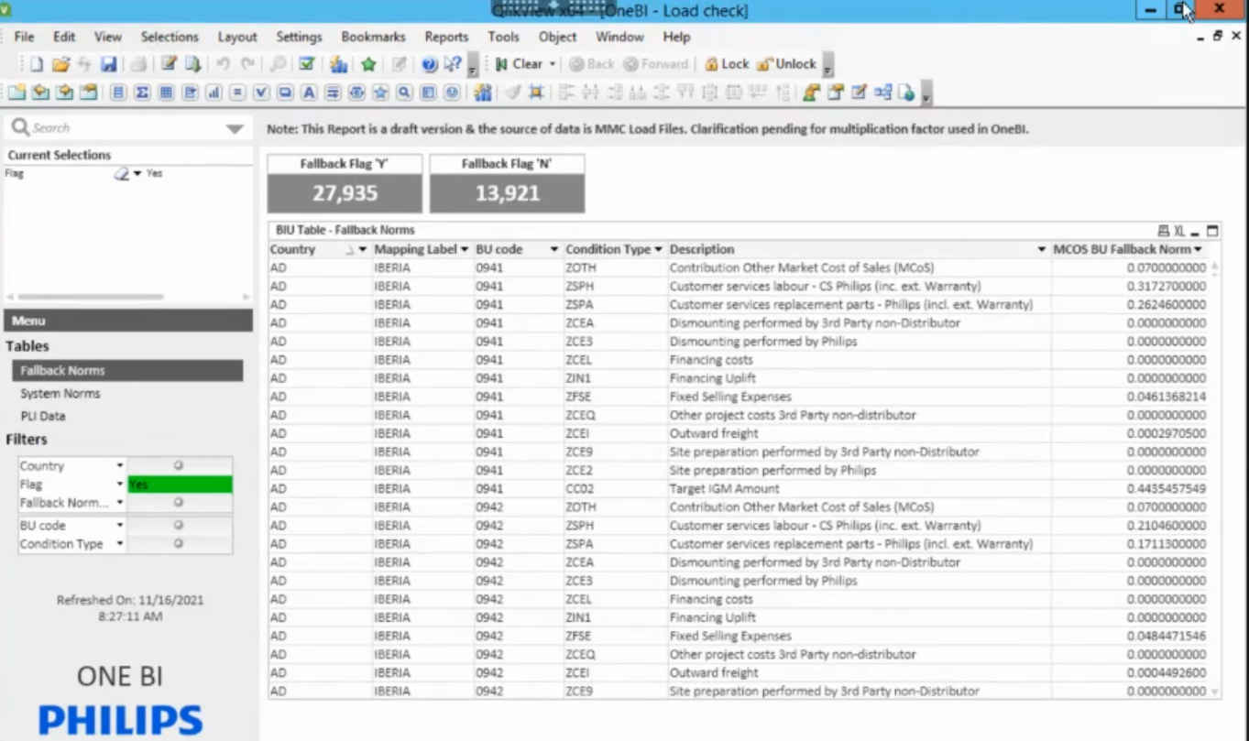

1. One BI Presentation Layer-zip file

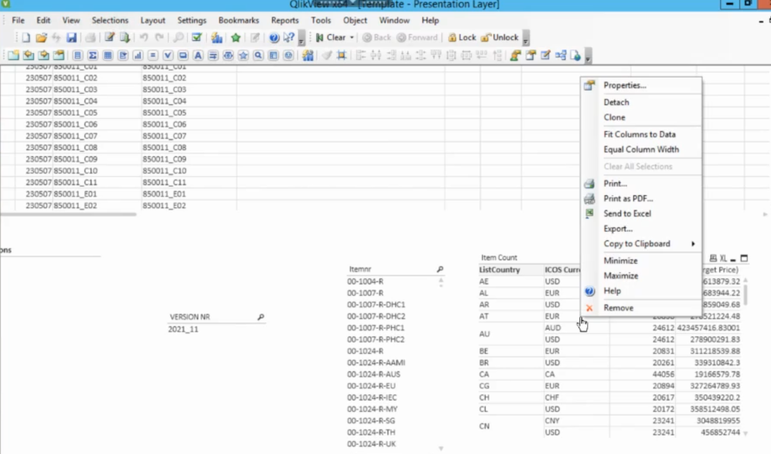

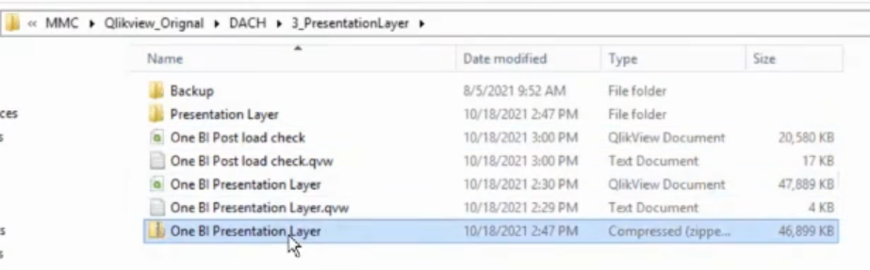

1. Refresh task in QMC.

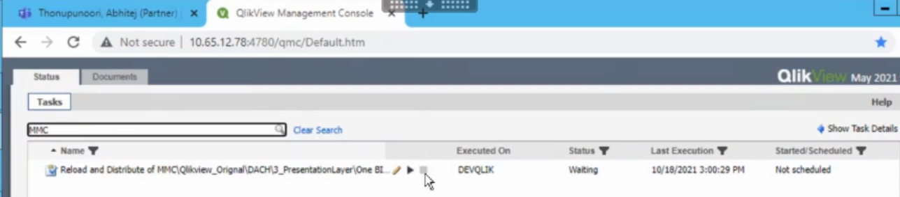

1. Take One BI presentation Layer zip file.

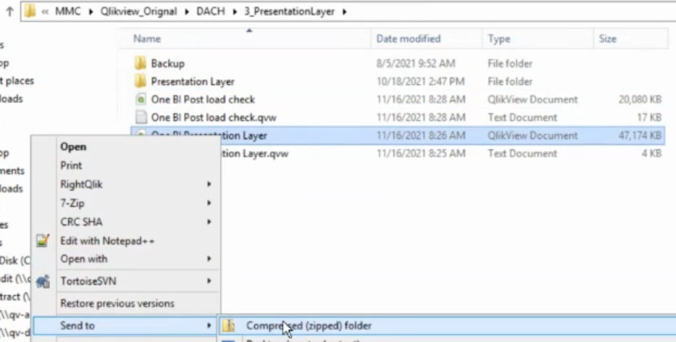

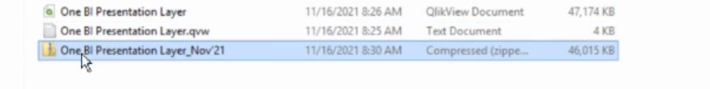

1. Take all the 7_Documents folder files into local.
2. Take Counts file from step 11

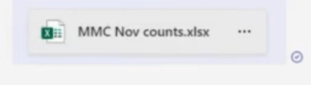

**Output File Processing:**

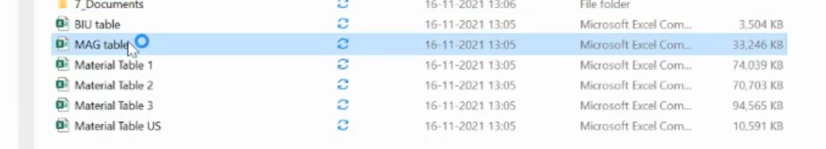

1. **MAG table:**

* Open the file and save as “xlsx”.

1. **All four Material tables:**

* D ,E column -- Text to columns -> delimited -> text -> finish.
* AI to AR -- format cells -> number -> decimal (5) -> use 1000 sep -> ok
* Save as xlsx

1. **BIU table:**

* First row -> text to columns -> general -> finish
* Select all -> Remove Duplicates
* E to W – copy into new excel file -> A to U -> save as “MMC Post Load Check” -> copy headers A to U paste next to V column -> write B*1 -> repeat for all the cells -> place back data to E to X in BIU table.
* X to AP -> format cells -> number (10) -> use 1000 separator -> finish.
* Save as xlsx

1. **Upload back all the files into MS Teams folder.**

**Monthly MMC Files -> General -> Files -> MMM YY**

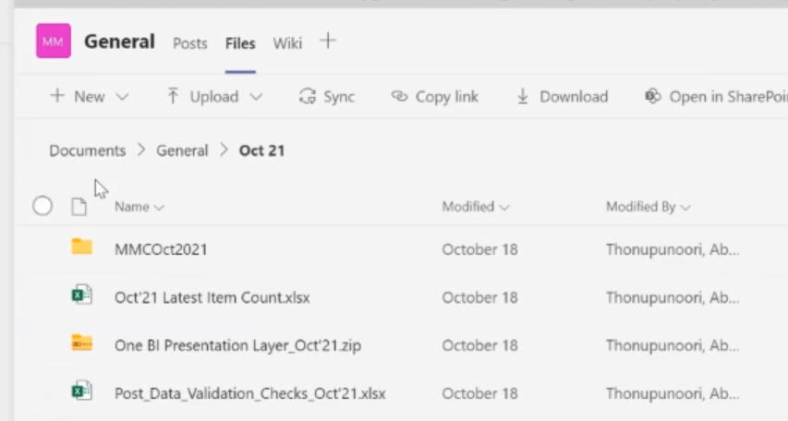

ONE BI - SALO2

1. Download dump for one BI post load check for Fallback norms, System Norms, PLI data with flag selected “Yes”.

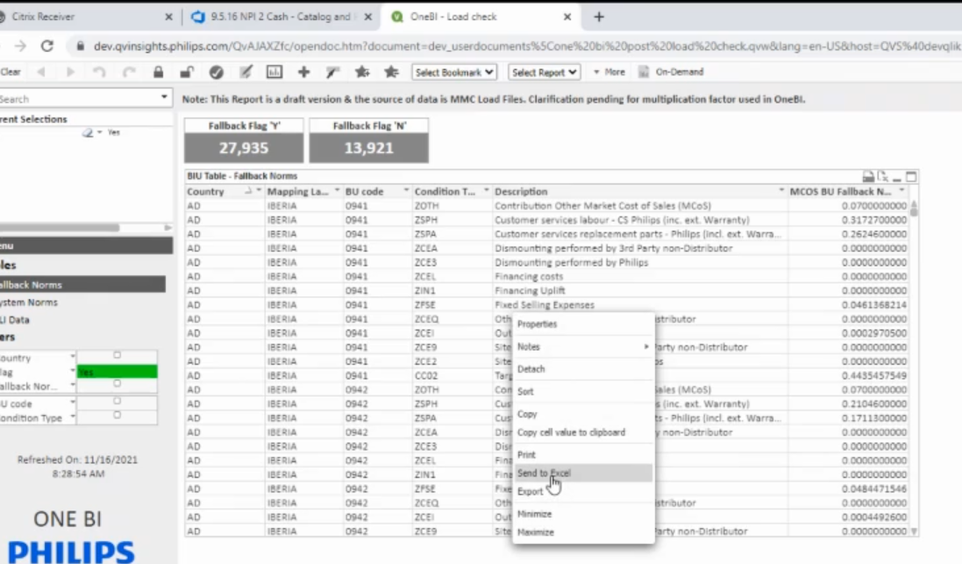

1. Verify once all the rows inside excel and at access point are same and decimal range match.
2. Place all three excel updated with name as per previous month inside Teams folder path:

**OneBI CR - Addition of Norms & PLI => General => Files => One Bi Post Load Check => New folder(YYYYMM)**

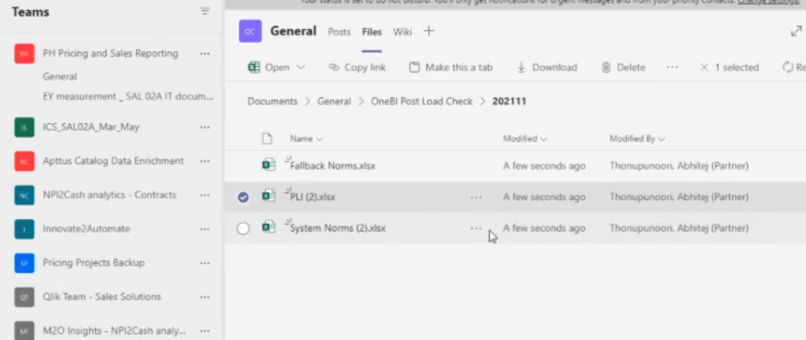

1. Mail back to Twan saying upload was done.

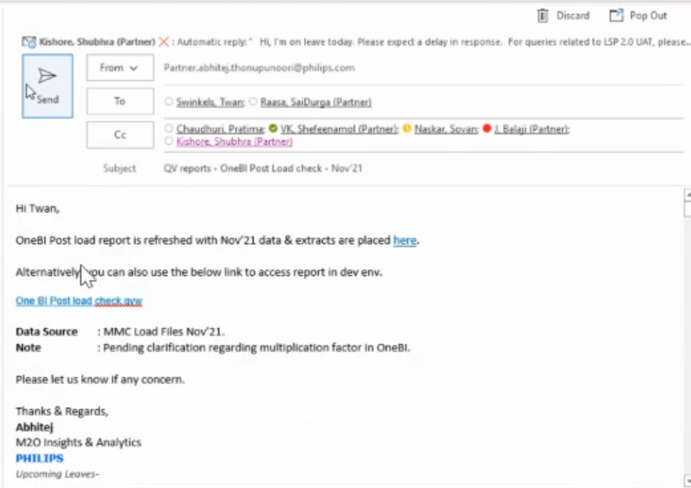

1. Send mail to Radhika nd Nisha.

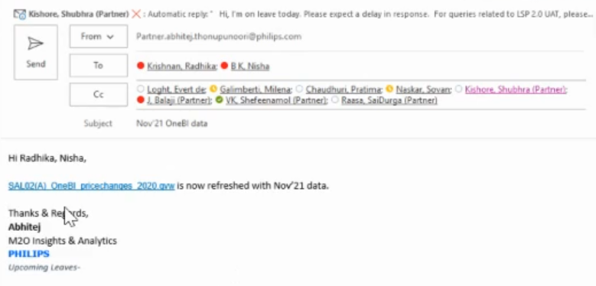

1. Post MMC refresh, we will get updated qvd on 21st every month inside 1BI_extract and EY_audit folder.
2. Should check whether we got updated QVD in both folders if we don’t find in EY_audit, should copy from 1BI_extract folder.

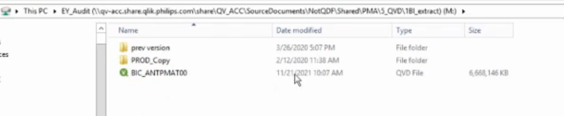

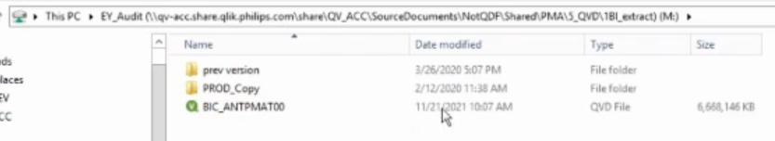

**Data Layer:**

**CPQ ACC -> Data Layer**

1. Refresh latest **SAL02(A)_OneBI_pricechanges_datalayer_2020** QVD.

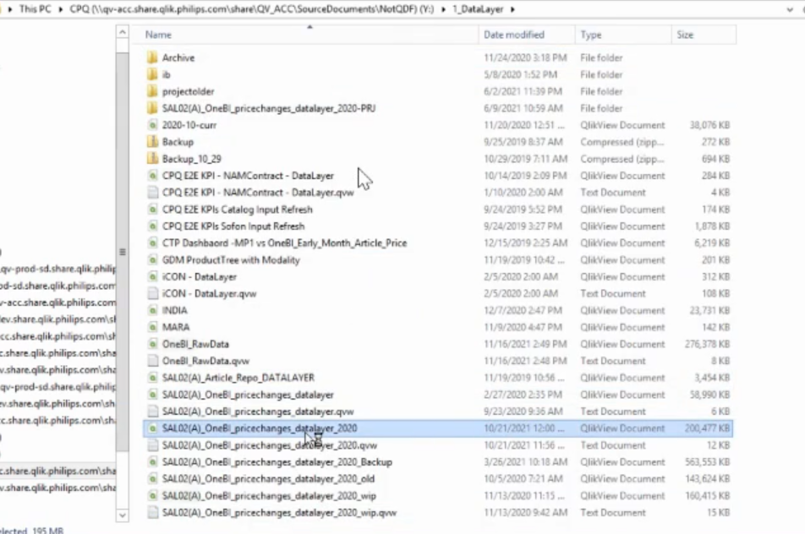

1. Once refresh completed check whether the version number got updated and same reflects on the data fields or not.

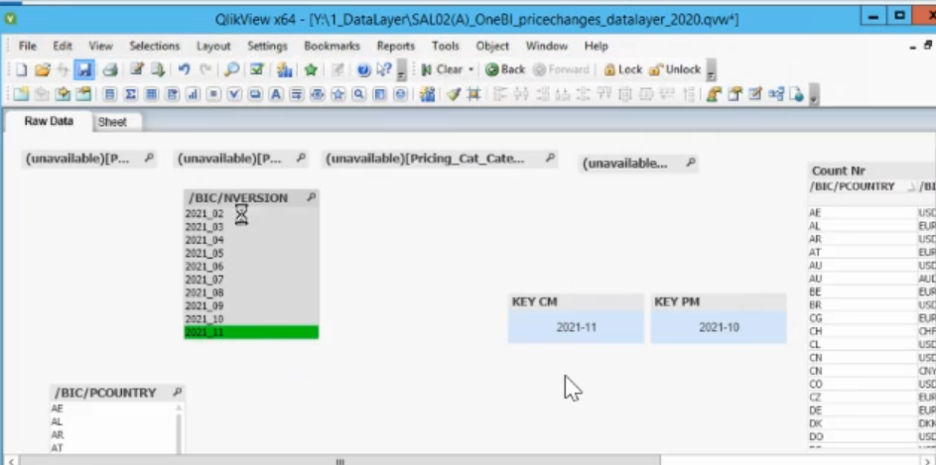

1. Also validate whether the Target Price match with output obtained during MMC run.

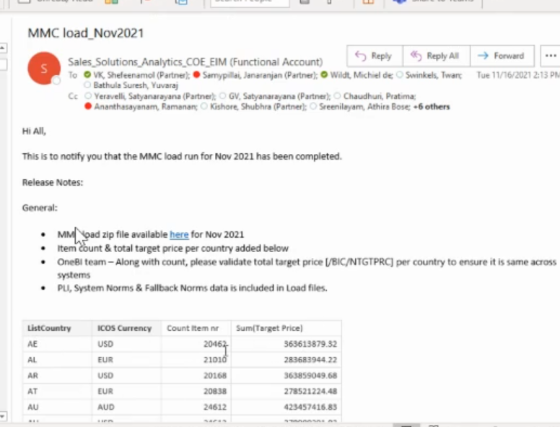

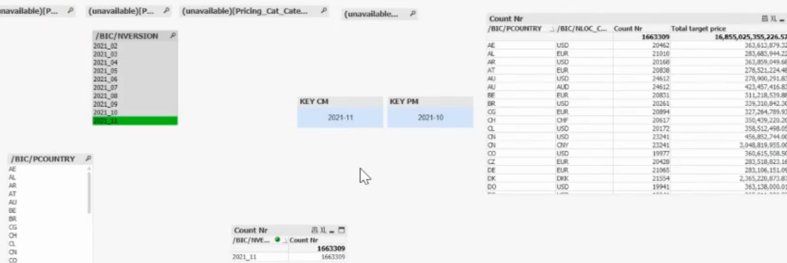

1. If it doesn’t matches, should report to respective POC (Twan and team).

**Business Layer:**

1. Refresh **SAL02(A)_ OneBI_pricechanges_2020** QVD.

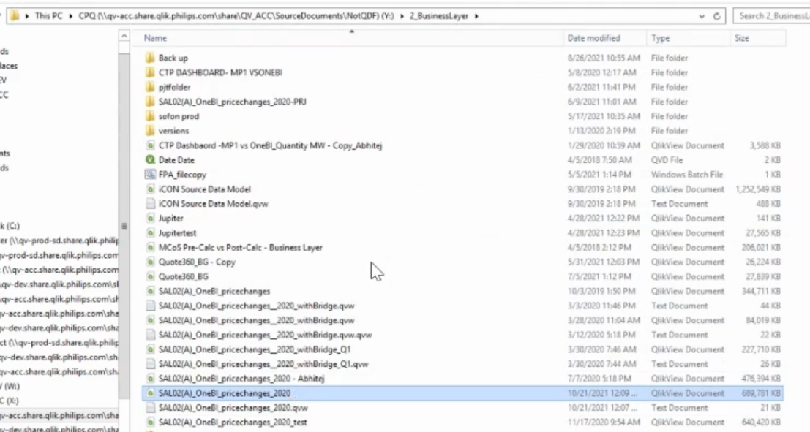

**Presentation Layer:**

1. Refresh **SAL02(A)_ OneBI_pricechanges_2020** QVD.

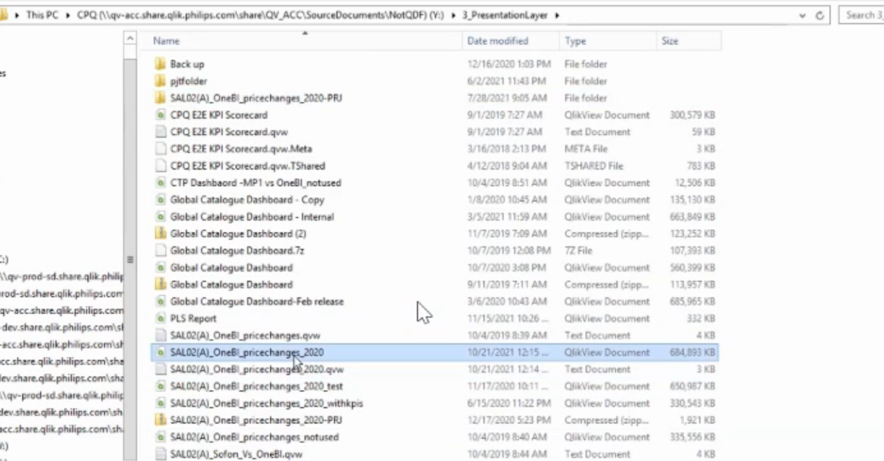

**14)Layer run presentation layer task from QMC.**

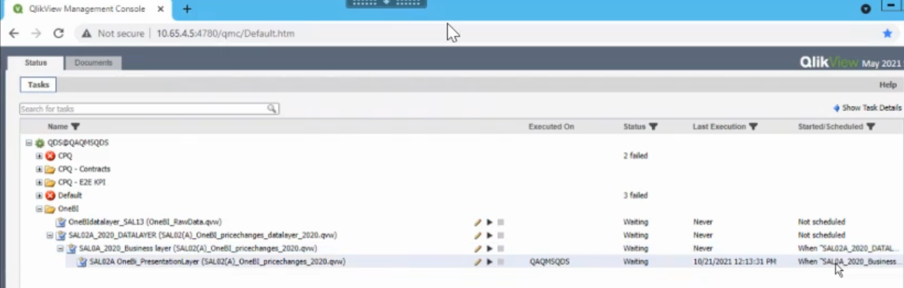

**Validation:**

1. Select any country and any article number.

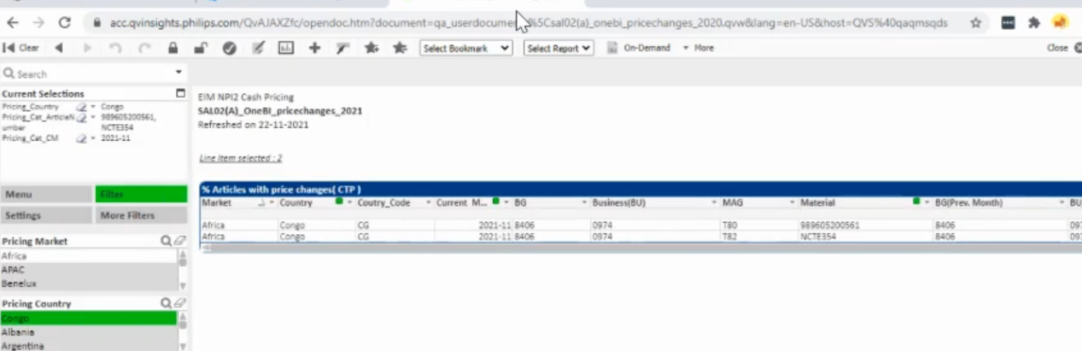

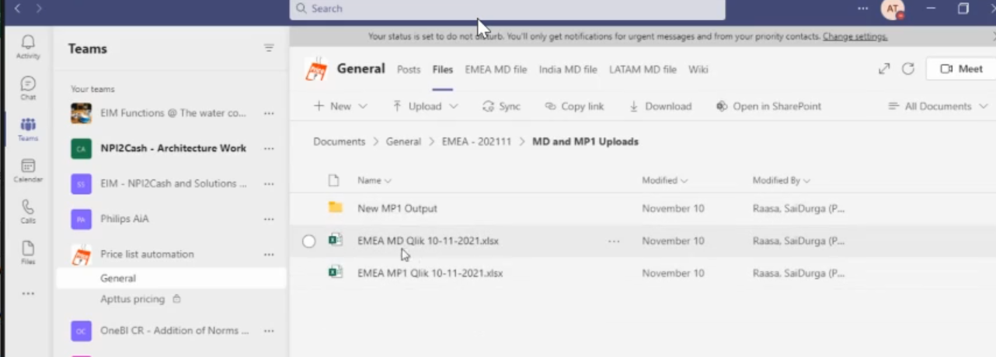

1. Check current month CTP from emea dashboard and last month from above located files.
2. Once process completed update completed in devops.

